Marriage Rates and the Tax Wedge

Mary Papayan

ECON 5200

Marriage Rates and the Tax Wedge

The subject of this paper concerns the relationship between income taxes and the marriage rates. Alm and Whittington (1995) considered that people take marriage decisions based on a variety of economic factors like income, female wages, education, unemployment, and (female) labor supply. The factors play an important and statistically significant role in the marriage decision. This paper demonstrates that the difference in taxes paid by couples, having two children with the other partner having a higher than 33% and 67% average income, influence significantly (confidence level is 90%) the marriage decision compared to singles having no children. This research uses data from the OECD (2017) gathered in the United States and Italy. The results reflect the literature findings as regards the outcome of this research for the United States and in Italy.

The first time income tax was mentioned in the United States was during the war of 1812. The idea of tax was taken from the British Tax Act of 1798. The British tax law imposed progressive tax rates on income. The British income tax rates ranged from .83 percent to ten percent depending on an individual’s income.

In the United States the tax system has been evolving throughout time. America did not always charge income taxes. The proposal to charge tax was developed in 1814 but was never imposed till later. In 1861 the first income tax was created during the Civil War as a mechanism to finance the war. In addition, in 1862 Congress passed the Internal Revenue act. However, income tax laws did not last long and were renewed later in 1872. After the Civil War income tax began to not gain support. Therefore, in 1894 congress passed another act called the Wilson Groman Tariff. The Wilson Groman Tariff was an income tax of two percent for income over four thousand dollars but this act was overturned by the Supreme Count in 1895. In the twentieth century income tax became supported and renewed. On February 1913 personal income tax was officially added into the constitution under the sixteenth amendment granting Congress power to collect taxes. This new system collected taxes before the income reached the recipient. The Revenue Act of 1916 created the practice of adjusting income scales and tax rates. The initial income tax was one percent for the bottom bracket which was income lower than twenty thousand and seven percent for the top bracket of income over five hundred thousand dollars. Later, the Revenue act of 1916 increased the bottom bracket to two percent and the top bracket to twenty five percent.

Similar to the United States, Italy also uses progressive income tax. However, Italy’s tax system is known to be one of the most complex in the world. Since the late 1990s the Italian government has been using tax cuts and incentives to simulate economic growth. On October 25, 2001 Italy’s inheritance tax was eliminated by Parliament. In 2003, personal income tax rates were reduced but this didn’t last long. In 2005 individual tax rate progressively increased for the top bracket of thirty nine percent. Sine then another four percent push has happened taking the top rate to forty three percent. These policies not only affected the economy but also had an affect on the decisions individuals made due to their new budget constraints.

Oikonomou and Siegel (2015) studied the impact of capital and labor taxation in the United Statess economy where couples bargain over the intra-household allocation under limited commitment. They noted that wealth, in contrast to labor income, is a commonly held resource within households. Although eliminating capital taxes from the economy, and raising labor taxes to balance the government’s budget may generate welfare gains to married households, the impact of labor income taxes on household risk sharing is small. Higher labor taxes may make a potential couple’s commitment to decide whether to marry and as a result may make the distribution of labor income more equitable within the household.

For the purposes of the research analysis, the following definitions are used: (a) a tax wedge is the difference between before-tax and after-tax wages; and (b) marriage tax (or subsidy) is defined as the increase (or decrease) in the joint income tax liability upon marriage. The behavioral effects of large marriage tax consequences have been examined and found to be significant for some aspects of marital behavior (e.g. spousal labor supply) (Alm & Whittington, 1995).

Alm and Whittington (1995) demonstrated the tax consequences of marriage up till 1987. The objective of this research paper is to demonstrate whether the tax wedge is related to the marriage rates. The economics of marriage has been increasingly studied, and economic incentives have been found to play a major role in the marriage decision, both in developed and in developing countries. This paper analysis the marriage rates between 2000 and 2014 based on data for the United States and Italy as assembled by the OECD (2017).

# Statistical Analyses

For this thesis statement, the research questions are formulated as follows:

(1) How accurately can the marriage rate be predicted from a linear relationship of the tax wedge in the United States and Italy?

(2) What is the relationship between the predictor of the tax wedge and the marriage rate in the United States and Italy?

Based on these research questions, the null and alternative hypotheses are formulated.

H10: The variable tax wedge does not contribute significantly to a linear model that explains the marriage rate in the United States and Italy.

H1a: The variable tax wedge contributes significantly to a linear model that explains the marriage rate in the United States and Italy.

H20: A significant relationship does not exist between the variable tax wedge and the marriage rate in the United States and Italy.

H2a: A significant relationship exists between the variable tax wedge and the marriage rate in the United States and Italy.

The dataset of economic data was gathered from the OECD (2017) and are depicted in Tables 1a and 1b. For the Marriage Rate, the crude rates are used and affect the number of marriages per 1000 people. The descriptive statistics of the various variables used are shown in Table 2. Taxing Wages provide unique information on income tax paid by workers and social security contributions levied on employees and their employers in OECD countries (OECD, 2017). In addition, this annual publication specifies family benefits paid as cash transfers. Amounts of taxes and benefits are depicted for three households, in the United States and Italy: (a) Single person (not married) at 100% of average earnings, no child, (b) two-earner married couple, one at 100% of average earnings and the other at 33 %, having 2 children, and (c) two-earner married couple, one at 100% of average earnings and the other at 67 %, having 2 children.

Table 1a  
*OECD Economic Data for the United States*

|  |  |  |  |  |  |  |
| --- | --- | --- | --- | --- | --- | --- |
| Year | Tax wedge (%)  Married couple -  33% | Tax wedge (%)  Married couple - 67% | Tax wedge  Not married | Difference  Taxwedge 33% | Difference  Taxwedge  67% | Marriage  Rate |
|  |  |  |  |  |  |  |
| 2000 | 24.95624 | 26.892182 | 30.843152 | 5.886912 | 3.95097 | 8.5 |
|  |  |  |  |  |  |  |
| 2001 | 24.496371 | 26.508095 | 30.739565 | 6.243194 | 4.23147 | 8.2 |
|  |  |  |  |  |  |  |
| 2002 | 24.438523 | 26.425428 | 30.584252 | 6.145729 | 4.158824 | 7.8 |
|  |  |  |  |  |  |  |
| 2003 | 22.484489 | 24.824869 | 30.460411 | 7.975922 | 5.635542 | 7.7 |
|  |  |  |  |  |  |  |
| 2004 | 22.633823 | 24.932743 | 30.482758 | 7.848935 | 5.550015 | 7.8 |
|  |  |  |  |  |  |  |
| 2005 | 22.690228 | 24.958022 | 30.418159 | 7.727931 | 5.460137 | 7.6 |
|  |  |  |  |  |  |  |
| 2006 | 22.9924 | 25.199247 | 30.552005 | 7.559605 | 5.352758 | 7.3 |
|  |  |  |  |  |  |  |
| 2007 | 23.471354 | 25.58309 | 30.917168 | 7.445814 | 5.334078 | 7.3 |
|  |  |  |  |  |  |  |
| 2008 | 21.003099 | 23.696141 | 30.061773 | 9.058674 | 6.365632 | 7.1 |
|  |  |  |  |  |  |  |
| 2009 | 22.551769 | 24.933366 | 30.278889 | 7.72712 | 5.345523 | 6.8 |
|  |  |  |  |  |  |  |
| 2010 | 23.02491 | 25.30856 | 30.747766 | 7.722856 | 5.439206 | 6.8 |
|  |  |  |  |  |  |  |
| 2011 | 22.644372 | 24.629648 | 29.905917 | 7.261545 | 5.276269 | 6.8 |
|  |  |  |  |  |  |  |
| 2012 | 22.692519 | 24.680569 | 29.842844 | 7.150325 | 5.162275 | 6.8 |
|  |  |  |  |  |  |  |
| 2013 | 24.328201 | 26.338734 | 31.450768 | 7.122567 | 5.112034 | 6.8 |
|  |  |  |  |  |  |  |
| 2014 | 24.607642 | 26.56007 | 31.641234 | 7.033592 | 5.081164 | 6.9 |
|  |  |  |  |  |  |  |

The descriptive statistics of the various variables used in this study were taken from the OECD (2017), regrouped and recalculated to calculate the difference in the tax wedges. These results are shown in Table 2. Correlations can also be calculated using regression analysis but nonetheless both procedures were carried out, as the correlations between the predictors needed to be established. First the correlations are examined. The indicators that indicate the relative strength of the individual predictors are displayed in Table 3. The Differences of the Tax Wedges had correlations with the

Table 1b  
*OECD Economic Data for Italy*

|  |  |  |  |  |  |  |
| --- | --- | --- | --- | --- | --- | --- |
| Year | Tax wedge (%)  Married couple -  33% | Tax wedge (%)  Married couple - 67% | Tax wedge  Not married | Difference  Taxwedge 33% | Difference  Taxwedge  67% | Marriage  Rate |
|  |  |  |  |  |  |  |
| 2000 | 41.067458 | 44.174772 | 47.080116 | 6.012658 | 2.905344 | 5.0 |
|  |  |  |  |  |  |  |
| 2001 | 40.494683 | 43.387055 | 46.573693 | 6.07901 | 3.186638 | 4.6 |
|  |  |  |  |  |  |  |
| 2002 | 39.185387 | 42.510861 | 46.550047 | 7.36466 | 4.039186 | 4.7 |
|  |  |  |  |  |  |  |
| 2003 | 38.241061 | 41.745462 | 45.973631 | 7.73257 | 4.228169 | 4.6 |
|  |  |  |  |  |  |  |
| 2004 | 38.581941 | 42.109272 | 46.283141 | 7.7012 | 4.173869 | 4.3 |
|  |  |  |  |  |  |  |
| 2005 | 38.255224 | 41.697295 | 45.904517 | 7.649293 | 4.207222 | 4.3 |
|  |  |  |  |  |  |  |
| 2006 | 39.136239 | 41.91749 | 46.054402 | 6.918163 | 4.136912 | 4.2 |
|  |  |  |  |  |  |  |
| 2007 | 37.842365 | 41.152371 | 46.388348 | 8.545983 | 5.235977 | 4.3 |
|  |  |  |  |  |  |  |
| 2008 | 38.600666 | 41.652334 | 46.645578 | 8.044912 | 4.993244 | 4.2 |
|  |  |  |  |  |  |  |
| 2009 | 38.923915 | 41.906728 | 46.791249 | 7.867334 | 4.884521 | 3.9 |
|  |  |  |  |  |  |  |
| 2010 | 39.576535 | 42.483068 | 47.175866 | 7.599331 | 4.692798 | 3.7 |
|  |  |  |  |  |  |  |
| 2011 | 40.186378 | 43.038448 | 47.596501 | 7.410123 | 4.558053 | 3.4 |
|  |  |  |  |  |  |  |
| 2012 | 40.465645 | 43.247464 | 47.722719 | 7.257074 | 4.475255 | 3.5 |
|  |  |  |  |  |  |  |
| 2013 | 40.290095 | 43.072916 | 47.838911 | 7.548816 | 4.765995 | 3.2 |
|  |  |  |  |  |  |  |
| 2014 | 38.885767 | 41.898916 | 47.780933 | 8.895166 | 5.882017 | 3.1 |
|  |  |  |  |  |  |  |

Table 2  
*Descriptive Statistics for All Variables*

|  |  |  |  |  |  |  |
| --- | --- | --- | --- | --- | --- | --- |
| Variable | Mean | Standard Deviation | Standard Error | | Range | |
| *US* Marriage Rates | 7.346 | 0.564 | 0.146 | | 6.776- 8.500 | |
|  |  |  |  |  | |
| *US* Differences Tax Wedge 33% | 7.327 | 0.804 | 0.804 | | 5.887- 9.059 | |
|  |  |  |  | |  | |
| *US* Difference Tax Wedge 67% | 5.164 | 0.624 | 0.624 | | 3.951– 6.366 | |
| *Italy* Marriage Rates | 4.067 | 0.577 | 0.149 | | 3.100-5.000 | |
|  |  |  |  | |  | |
| *Italy* Difference Tax Wedge 33% | 7.508 | 0.768 | 0.198 | | 6.013-8.895 | |
|  |  |  |  | |  | |
| I*taly* Difference Tax Wedge 67% | 4.424 | 0.744 | 0.192 | | 2.905-5.882 | |
|  |  |  |  | |  | |

Table 3  
*Bivariate Correlations (2-tailed))* *for the Predictors and the Marriage Rate*

|  |  |  |  |  |  |
| --- | --- | --- | --- | --- | --- |
| Predictors | | Correlation between Marriage Rate and predictor | | Significance | |
|  |  | |  | |
| *US* Differences Tax Wedge 33% (2-tailed) | -.486 | | .066 | |
|  |  | |  | |
| *US* Difference Tax Wedge 67%(2-tailed) | -.570 | | .027 | |
|  |  | |  | |
| *Italy* Differences Tax Wedge 33% (2-tailed) | -.497 | | .060 | |
| *Italy* Difference Tax Wedge 67% (2-tailed) | -.717 | | .003 | |
|  |  | |  | |

Marriage Rates ranging from , and for the United States and from , and respectively. All the correlations between the Differences of the Tax Wedge and the Marriage Rate were negative and statistically significant, as the confidence level was set at 90%. These results imply that higher tax wedges induces fewer marriages, demonstrating that inequalities of incomes do not induce couples to be married.

Given the intermediary results and conclusions based on these descriptive and correlation statistics, regression analyses were carried out to answer the two research questions. Regression were executed under a Confidence Level interval at 90% (α = 10%). One of the aims of performing a regression is to determine each independent variable's ability to explain the dependent variable. Under the random-effects model, other assumptions are that (a) the variables are normally distributed in the population; and (b) the cases represent a random sample from the population, and the scores on variables are independent of other scores of the same variables (Green & Salkind, 2010).

The *P-P* plots for the predictor variables Differences Tax Wedge 33% (left picture) and Differences Tax Wedge 66% (right picture) are depicted in Figures 1a and 1b. The regression residual plots for the criterion Marriage Rate are shown in Figure 3a and 3b. For the two variables Differences Tax Wedge 33% (left picture) and Differences Tax Wedge 67% the assumptions (a) can be

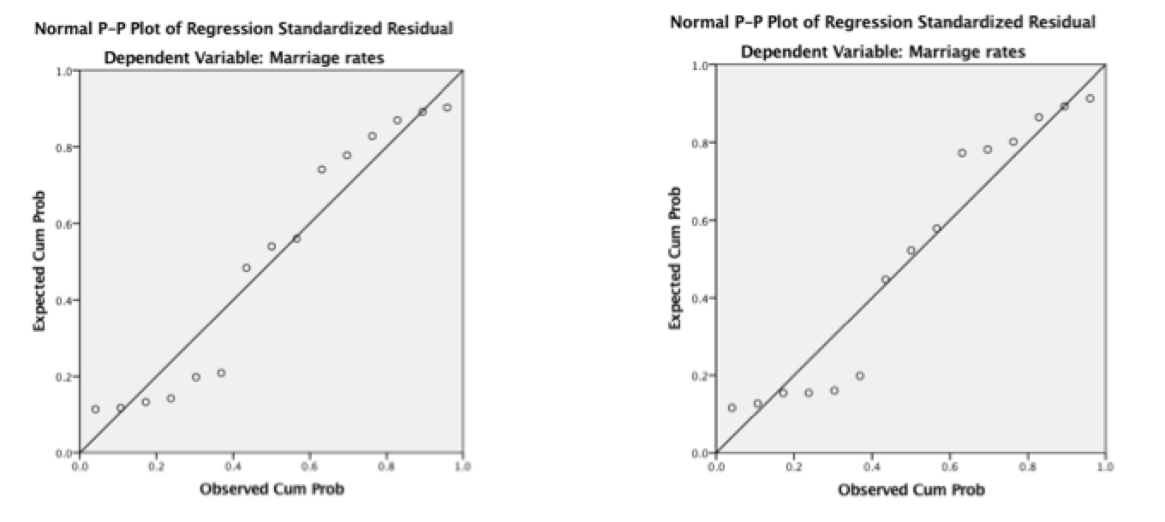*Figure 1a.* P-P plots for the Differences Tax Wedge (33% and 66%; left and right - United States.

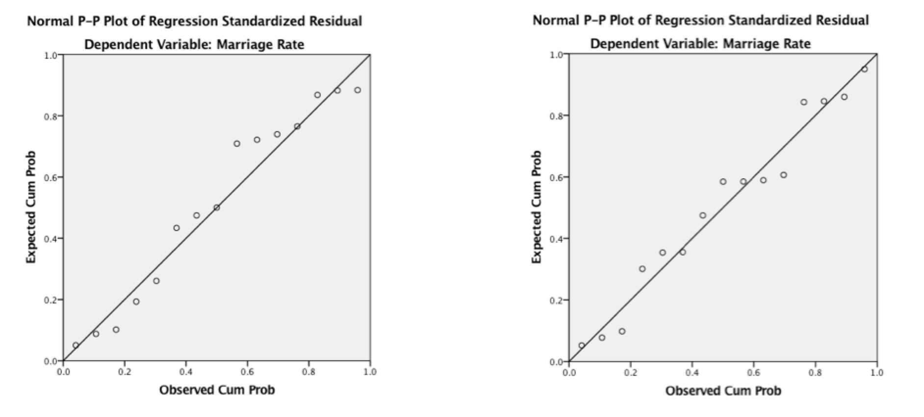

*Figure 1b.* P-P plots for the Differences Tax Wedge (33% and 66%; left and right - Italy.

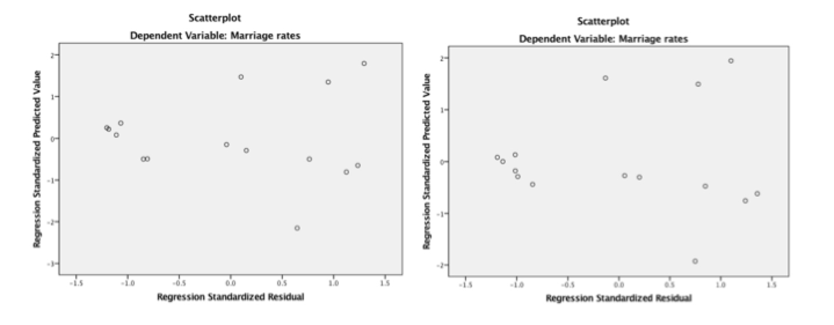

*Figure 2a.* Regression residual plots for the criterion Marriage Rate (33% and 66%; left and right) - United States.

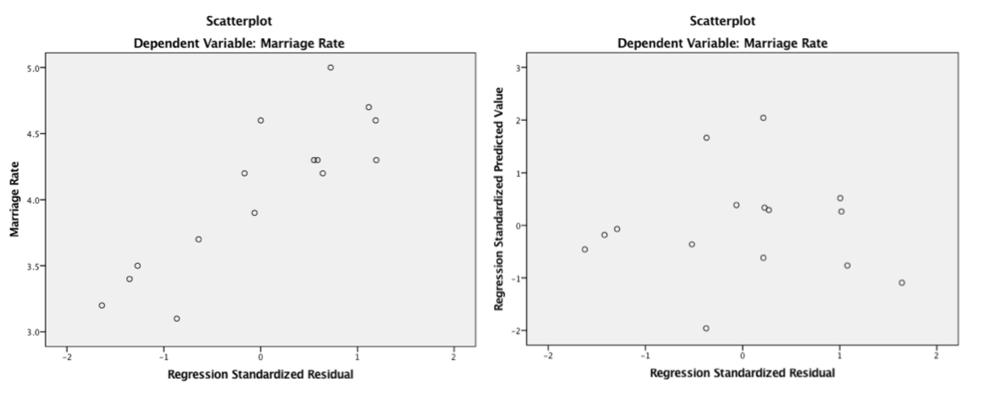

*Figure 2b.* Regression residual plots for the criterion Marriage Rate (33% and 66%; left and right) -Italy.

satisfactorily accepted, because (1) the predictor variables are mostly aligned to the expected normal values, and (2) the regression residual plot for the criterion Marriage Rate shows that the residuals are more or less symmetrically distributed about zero centered around the predictive value. Assumption (b) is also assumed despite the fact that some non-linearity effects due to correlations between the predictor variables are expected.

Table 4  
*Coefficients for Two Models (Differences Tax Wedge 33% and Differences Tax Wedge 66%) for the Marriage Rate*

|  |  |  |  |  |  |  |  |  |  |  |  |  |
| --- | --- | --- | --- | --- | --- | --- | --- | --- | --- | --- | --- | --- |
| Model | | Unstandardized Coefficients | |  | Standardized Coefficients | *t* | Sig.  *p* value | 90.0% Confidence Interval for B | | |  | Correlations |
| B | Std. Error |  | Beta |  |  | Lower Bound | | Upper Bound |  | Zero-order |
| 1 | (Constant) | 9.843 | 1.253 |  |  | 7.852 | 0.000 | | 7.623 | 12.063 |  |  |  |  |
| *Differences Tax Wedge 33% US* | -0.341 | 0.170 |  | -0.486 | -2.003 | 0.066 | | -0.642 | -0.039 |  | -0.486 |
| 2 | (Constant) | 10.005 | 1.071 |  |  | 9.340 | 0.000 | | 8.108 | 11.902 |  |  |
|  | *Differences Tax Wedge 67% US* | -0.515 | 0.206 |  | -0.569 | -2.499 | 0.027 | | -0.878 | -0.150 |  | -0.5697 |
|  |  |  |  |  |  |  |  | |  |  |  |  |
| 3 | (Constant) | 6.866 | 1.364 |  |  | 5.0349 | 0.00 | | 4.451 | 9.281 |  |  |
|  | *Differences Tax Wedge 33% Italy* | -0.373 | 0.181 |  | -0.496574 | -2.0627 | 0.060 | | -0.693 | -0.053 |  | -0.497 |
| 4 | (Constant) | 6.526 | 0.671 |  |  | 9.722 | 0.000 | | 5.338 | 7.715 |  |  |
|  | *Differences Tax Wedge 67% Italy* | -0.556 | 0.150 |  | -0.717332 | -3.712 | 0.003 | | -0.821 | -0.291 |  | -0.717 |
|  |  |  |  |  |  |  |  | |  |  |  |  |

Four models were evaluated based on the independent variables Differences Tax Wedge 33% and Differences Tax Wedge 66% for which the sums of squares for error are minimal, both for the United States and Italy. The models summaries, based on ANOVA analyses, are depicted in Table 4. The regression plots between the predictors and the Marriage Rate are shown in Figure 3a and 3b.

# Conclusions

To summarize the discussion and analyses, bi-variate regression analyses were conducted to evaluate how well the differences in the tax wedge for two groups for which the other partner has different higher average incomes measure the Marriage Rate, both in the United States and Italy. The predictors were the variables Differences Tax Wedge 33% and Differences Tax Wedge 66%, while the

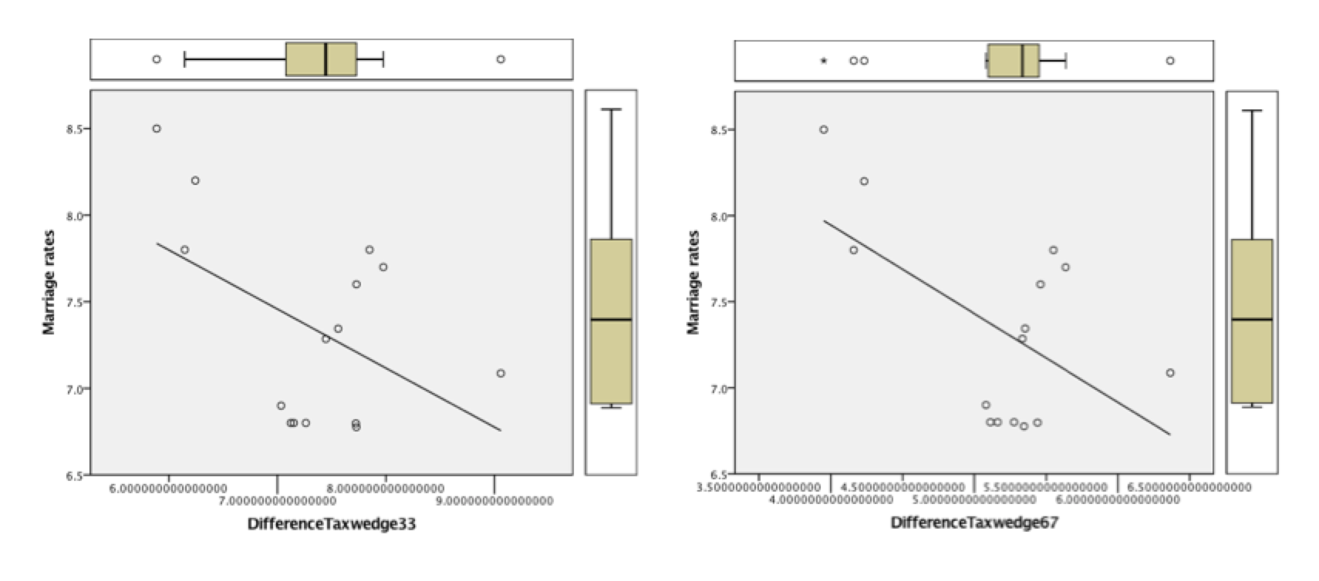

*Figure 3a.* Regression plots between the predictors (Differences Tax Wedge 33% (left) and 67% (right)) and the Marriage Rate for the United States.

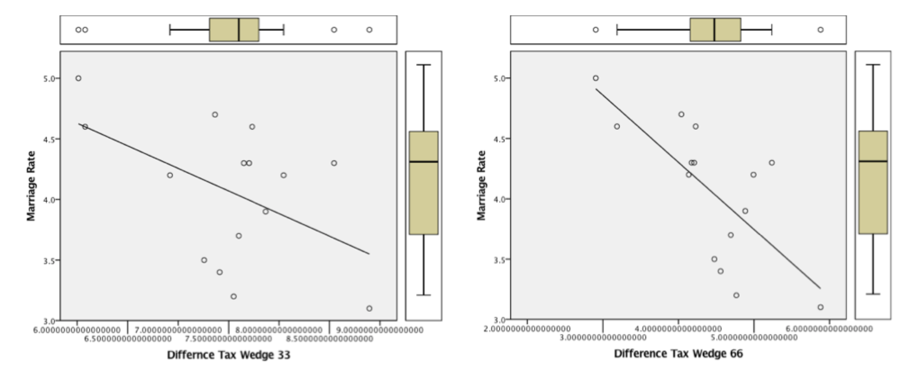

*Figure 3b.* Regression plots between the predictors (Differences Tax Wedge 33% (left) and 67% (right)) and the Marriage Rate for Italy.

criterion variable was the Marriage Rate. Either independent variables Differences Tax Wedge 33% and Differences Tax Wedge 67% were significantly related to the Marriage Rate, *F*(1, 13) = 4.01 and *F*(1, 13) = 6.25 for the United States and *F*(1, 13) = 4.26 and *F*(1, 13) = 13.78 r for Italy respectively. The correlation coefficients *r*(13) were -.486 and -.570 for the United States and -.497 and -.717 for Italy respectively, indicating that approximately 23.6% and 32.5% for the Unites States and 24.7% and 51.5% of the variance (*R*2) of the Marriage Rate in the economic data can be accounted for by the linear relationship of the Marriage Risk associated to the tax wedges of the two income groups.

The Marriage Rates (MR) can be significantly ( predicted by the following equations:

MRUS (33%) = 9.84 - 0.34DTaxW33%, (1a)

MRUS (67%) = 10.01 - 0.51DtaxW67%, (1b)

MRItaly (33%) = 6.86 - 0.37DTaxW33%, (2a)

MRItaly (67%) = 6.53 - 0.56DtaxW67%. (2b)

with significances of *p* = 0.07 and *p* = 0.03 for the Unites States and *p* = 0.06 and *p* = 0.003 for Italy respectively. The confidence levels were set at a 90% level in conformance to Alm and Whittington’s (1995) research.

These results do not support the hypothesis that a significant relationship does not exist between the variable tax wedge and the marriage rate in the United States and Italy. The first null hypothesis is rejected. Also, based upon above results, the hypothesis is not supported that a significant relationship does not exist between the variables Differences Tax Wedge 33% and Differences Tax Wedge 66% and the Marriage Rate, both for the United States and Italy. The second null hypothesis is rejected. For Italy, *p <* 1% for the Marriage Rate for married couples (2 children) where 1 spouse earns 67% more than the other.

Comparing the Marriage Rates of the Unites States and Italy reveals that (a) the major difference is that the rate is higher for each difference in tax wedge in the Unites States, as the constant in equations (1a) and (1b) are higher; (b) the slopes of the Differences in the tax wedges are higher in Italy; and (c) the effect of the tax wedge (from 33% to 67%) in Italy has greater impact in Italy than in the United States.

Although there is a lot of variation in average income between individuals, the results of this research confirm that the behavioral effects of large marriage tax or the tax wedge have significant effects on marital behavior. People tend not to be married, the higher their spouses’ incomes are (Alm & Whittington, 1995). When income taxes increase with marriage, the aggregate marriage rate declines. However, the level of this impact can be quite small (Alm & Whittington, 1995). Some individuals respond to tax incentives in their marriage choices, but for many individuals taxes do not affect these decisions. This is illustrated by the relatively higher *R*2 value for couples having two children with the other partner having a higher than 67% average income, both for the Unites States and Italy. Hence, there are other factors that can explain the (aggregate) Marriage Rate in the United States. These factors have been studied in various countries, such as in Italy and in the United States (Colonna & Marcassa, 2015; Gayle & Shephard, 2015).

The outcomes of this study depended on the gains from marriage and the marriage rate as they correlate with the total taxes paid and on the marginal tax rate faced by couples versus single people. The results are corresponding with economic models of marriage explaining that the costs of being married increase relative to being single, and as a result individuals are less likely to marry (Alm & Whittington, 1995). Colonna and Marcassa (2015) noted that in Italy the participation rate of married women to the labor force is positively correlated with their husbands’ income. The results in this paper highlight the fact that in Italy the high tax rate raises the burden of two-earner households, generating disincentives to work and to marry. However, in Italy married women tend to join the labor force, the higher the income of their spouses are. The tax wedge effects notably deviates from other countries in the European Union. Another conclusion out of these studies is that no progressive tax system can achieve both full marriage neutrality and horizontal equity across families, as inequality of incomes between spouses does not encourage marriages.

# Suggestions for Further Study

Areas of further study are building models where the participation of women to the labor force is investigated with its concomitant effects on marriage rates. For Italy, household income pooling will encourage women to participate in the labor market, especially for those married to high income husbands which is in contrast to other countries such as Spain in the European Union (Colonna & Marcassa, 2015). A possibility for further research in this regard is to investigate these effects also in the Unites States. Furthermore, other effects in both economies can be investigated having their effects on the marriage rates, such as the market wage of women, race, unemployment, education, immigration and the timing of marriage (Díaz-Giménez & Giolito, 2013).

References

Alm, J., & Whittington, L. A. (1995). Income taxes and the marriage decision. *Applied Economics*, *27*(1), 25-31. https://doi.org/10.1080/00036849500000004

Colonna, F., & Marcassa, S. (2015). Taxation and female labor supply in Italy. *IZA Journal of Labor Policy*, *4*(1), 5. doi:10.1186/s40173-015-0030-0

Díaz-Giménez, J., & Giolito, E. (2013). Accounting for the timing of first marriage. *International Economic Review, 54*(1), 135–158. doi:10.1111/j.1468-2354.2012.00728.x

Gayle, G.-L., & Shephard, A. (2015). Optimal Taxation, Marriage, Home Production, and Family Labor Supply. Federal Reserve Bank of St. Louis, Working Papers, 2015(010). doi:10.20955/wp.2015.010

Green, S. B., & Salkind, N. J. (2010)*. Using SPSS for Windows and Macintosh: Analyzing and understanding data.* Prentice Hall Press.

OECD (2017). OECD iLibrary Taxing Wages publication. http://stats.oecd.org/index.aspx?DataSetCode=TABLE_I3#

Oikonomou, R., & Siegel, C. (2015). Capital Taxes, Labor Taxes and the Household. *Journal of Demographic Economics*, *81*(3), 217-260. doi:10.1017/dem.2015.7